Soit la base de données

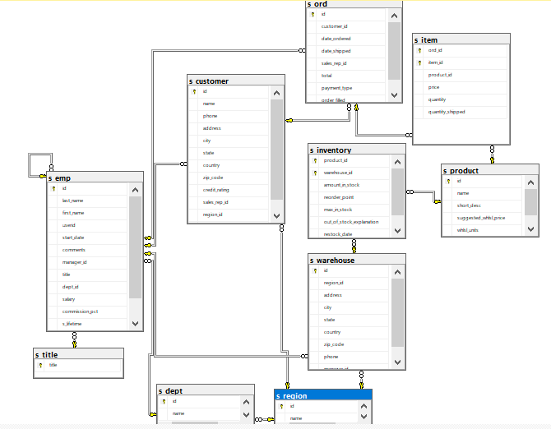

**S_customer**

id varchar(3) Unchecked

name varchar(20) Unchecked

phone varchar(20) Unchecked

address varchar(20) Checked

city varchar(20) Checked

state varchar(15) Checked

country varchar(20) Checked

zip_code varchar(15) Checked

credit_rating varchar(9) Checked values(Excellent,Good,Poor)

sales_rep_id varchar(3) Checked

region_id varchar(3) Checked

comments varchar(255) Checked

**S_Region**

id varchar(3) Unchecked PK

name varchar(20) Unchecked

**S_emp**

Id varchar (3) Unchecked PK

last_name varchar(20) Unchecked

first_name varchar(20) Checked

userid varchar(8) Unchecked UNIQUE

start_date date Unchecked

comments varchar(255) Checked

manager_id varchar(3) Checked

title varchar(25) Checked

dept_id varchar(3) Checked

salary decimal(11, 2) Checked

commission_pct decimal(4, 2) Checked Values(10, 12.5, 15, 17.5, 20)

s_lifetime int Checked

commission decimal(18, 0) Checked

**S_Inventory**

product_id varchar(7) Unchecked PK

warehouse_id varchar(7) Unchecked PK

amount_in_stock decimal(9, 0) Checked

reorder_point decimal(9, 0) Checked

max_in_stock decimal(9, 0) Checked

out_of_stock_explanation varchar(255) Checked

restock_date date Checked

**S_item**

ord_id varchar(3) Unchecked PK

item_id varchar(7) Unchecked

product_id varchar(7) Unchecked PK

price decimal(11, 2) Checked

quantity decimal(9, 0) Checked

quantity_shipped decimal(9, 0) Checked

**s_ord**

id varchar(3) Unchecked PK

customer_id varchar(3) Unchecked

date_ordered date Unchecked

date_shipped date Checked

sales_rep_id varchar(3) Checked

total decimal(11, 2) Checked

payment_type varchar(6) Unchecked values(‘Cash’, ‘Credit’)

order_filled varchar(1) Checked values(‘Y’,’N’)

**S_product**

id varchar(7) Unchecked PK

name varchar(25) Unchecked

short_desc varchar(255) Checked

suggested_whlsl_price decimal(11, 2) Checked

whlsl_units varchar(10) Checked

**S_region**

id varchar(3) Unchecked PK

name varchar(26) Unchecked

**S_Title**

title varchar(25) Unchecked PK

**S_warehouse**

id varchar(7) Unchecked PK

region_id varchar(3) Unchecked

address varchar(20) Checked

city varchar(20) Checked

state varchar(15) Checked

country varchar(20) Checked

zip_code varchar(15) Checked

phone varchar(20) Checked

manager_id varchar(3) Checked

**S_dept**

id varchar(3) Unchecked PK

name varchar(20) Unchecked

region_id varchar(3) Checked

**Rq** : Uncheked = NULL is not allowed Checked=NULL is allowed

**Data**

*Voir Excel file*